# Overview

This document contains the necessary information to build the device.

Contents

Overview 1

Maker Checklist 3

Maker To Do List 3

Items to Give to User 3

Tool List 4

Custom PCB Guide 5

Ordering the Controller PCB 5

Customization Guide 5

3D Printing Guide 6

3D Printing Summary 6

3D Printing Settings 6

Post-Processing 6

Examples of Quality Prints 6

Assembly Guide 7

Required Components 7

Required Tools 9

Required Personal Protective Equipment (PPE) 9

Assembly Instructions 10

Step 1: Insert and solder the 3.5 mm Jack 10

Step 2: Insert and solder the Solid-State Relay 10

Step 3: Insert and solder the Resistor 11

Step 4: Insert and Solder the Push Button 12

Step 5: Position and Solder the Power Switch 13

Step 5.1: Testing the Power Switch 14

Step 6: Insert and Solder the Digital Output Plug 15

Step 7: Insert and Solder the Trinket M0 Board 16

Step 8: Insert and Solder the Power Supply Board 17

Step 9: Score Between Pins on Power Supply Board 17

Step 10: Solder Power Supply Board to PCB 18

Step 11: Position and Glue the Light Pipe 18

Step 12: Final Assembly 19

Firmware Flashing Instructions 21

Step 1: Setup Arduino IDE 21

Step 2: Setup Arduino IDE for Adafruit Trinket M0 Board 21

Step 3: Install Libraries 21

Step 4: Setup Local Code Directory 21

Step 5: Upload the Code to the microcontroller. 21

Testing 22

# Maker Checklist

This list provides an overview of the steps required to build and deliver the device.

## Maker To Do List

* Read through the Assembly Guide to become familiar with required components, tools, supplies, and safety gear and overall assembly steps.
* Ask user if they have or need an assistive switch.
* Ask user if they have or need a switch accessible device (adapted toy, adapted mouse, switch interface, etc.).
* Talk to user about customization options (e.g., color, any special requests, etc.).
* Order hardware components.
* Gather tools, supplies, and safety equipment.
* Assemble the device.
* Test device.
* Print User Guide.

## Items to Give to User

* Assembled, tested device.
* User Guide.
* Micro-USB cable.

# Tool List

|  |  |
| --- | --- |
| * Fine-tipped soldering iron * Solder * Flush Cutters * Utility Knife * Breadboard or small clamp | * Electrical tape * Multimeter * Micro-USB cable * Accessible switch and switch tester (for testing) |

# 

# Custom PCB Guide

The Lift Switch uses one custom circuit board.

The Custom PCB can be ordered from one of a variety of PCB Manufacturers. Typically, the minimum quantity for a custom PCB is five. Shipping options vary significantly in cost and shipping time. Plan on at least a week from the time of order to the PCBs arrival.

## Ordering the Controller PCB

1. Select a PCB Fabrication Company
   1. [JLPCB](https://jlcpcb.com/)
   2. [PCBWay](https://www.pcbway.com/)
   3. [OSH Park](https://oshpark.com/)
   4. [Seeed Fusion PCB](https://www.seeedstudio.com/fusion_pcb.html)
2. Create an account or use a guest login.
3. Upload the Gerber Files.
4. Select the fabrication options:
   1. PCB Layers: 2 Layers
   2. PCB Quantity: 5
   3. PCB Thickness: 1.5 mm
   4. Surface Finish: HASL
   5. PCB Color: Choose what you like. Note that certain colors may impact build time.
   6. The default settings for the other settings should work.
5. Select shipping option.
   1. Shipping options and costs vary significantly. Select the best option based on your budget and timing.
6. Submit the order.

# Customization Guide

The device can be printed in the user’s desired colour.

# 3D Printing Guide

## 3D Printing Summary

|  |  |
| --- | --- |
| **Metrics** | **Single Unit** |
| Total Print Time (min) | 1:51 |
| Total Number of Components | 3 |
| Typical Total Mass (g) | 13.4 |
| Typical Number of Print Setups | 1 |

## 3D Printing Settings

|  |  |  |  |  |  |  |  |
| --- | --- | --- | --- | --- | --- | --- | --- |
| **Print File Name** | **Qty** | **Total Print Time (hr:min)** | **Mass (g)** | **Infill (%)** | **Support (Y/N)** | **Layer Height/ Nozzle Diameter(mm)** | **Notes** |
| Lift_Switch_Base | 1 | 0:41 | 5.2 | 20 | N | 0.2/0.4 |  |
| Lift_Switch_Top | 1 | 1:07 | 8.0 | 20 | N | 0.2/0.4 |  |
| Lift_Switch_Power_Switch | 1 | 0:03 | 0.2 | 20 | N | 0.2/0.4 |  |

## Post-Processing

* Remove any stringing or blobs

## Examples of Quality Prints

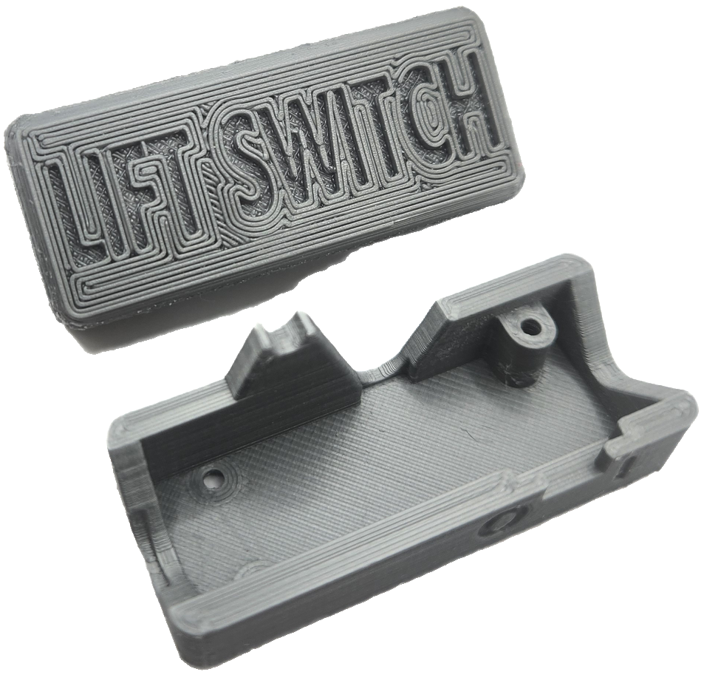 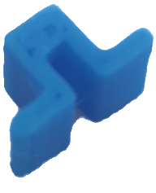

# Assembly Guide

## Required Components

|  |  |  |  |  |  |  |  |  |
| --- | --- | --- | --- | --- | --- | --- | --- | --- |
| **A** | Blank Lift Switch PCB | QTY 1 | **B** | Adafruit Trinket M0 Board | QTY 1 | **C** | Power Supply Board | QTY 1 |
|  | | |  | | |  | | |
| **D** | 3.5 mm jack/aux port | QTY 1 | **E** | Solid-state relay | QTY 1 | **F** | 330 Ω resistor | QTY 1 |
|  | | | フォトカプラ フォトリレー 60V0.5A TLP222AF | | |  | | |
| **G** | Push button | QTY 1 | **H** | Power switch | QTY 1 | **I** | 3.5 mm digital output plug | QTY 1 |
|  | | |  | | |  | | |

|  |  |  |  |  |  |  |  |  |
| --- | --- | --- | --- | --- | --- | --- | --- | --- |
| **J** | 5-pin headers | QTY 2 | **K** | 3-pin header | QTY 1 | **L** | 2-pin header | QTY 1 |
|  | | |  | | |  | | |
| **M** | Light pipe | QTY 1 | **N** | Lithium-ion polymer battery  (3.7V 110mAh) | QTY 1 | **O** | 3D-printed Lift Switch Case | QTY 1 |
|  | | |  | | |  | | |
| **P** | 3D-printed switch cover | QTY 1 | **Q** | M2 x 0.4 mm x 25mm screws | QTY 3 |
|  | | |  | | |

## Required Tools

|  |  |  |
| --- | --- | --- |
| Fine-tipped soldering iron | Solder | Flush Cutters |
| Utility knife | Breadboard or small clamp | Electrical tape |
| Multimeter | Micro-USB cable | Assistive Switch and Switch Tester (for testing) |

You will also need a personal computer with Arduino IDE software installed. See instructions for flashing the device.

## Required Personal Protective Equipment (PPE)

* Protective eyewear

## Assembly Instructions

### Step 1: Insert and solder the 3.5 mm Jack

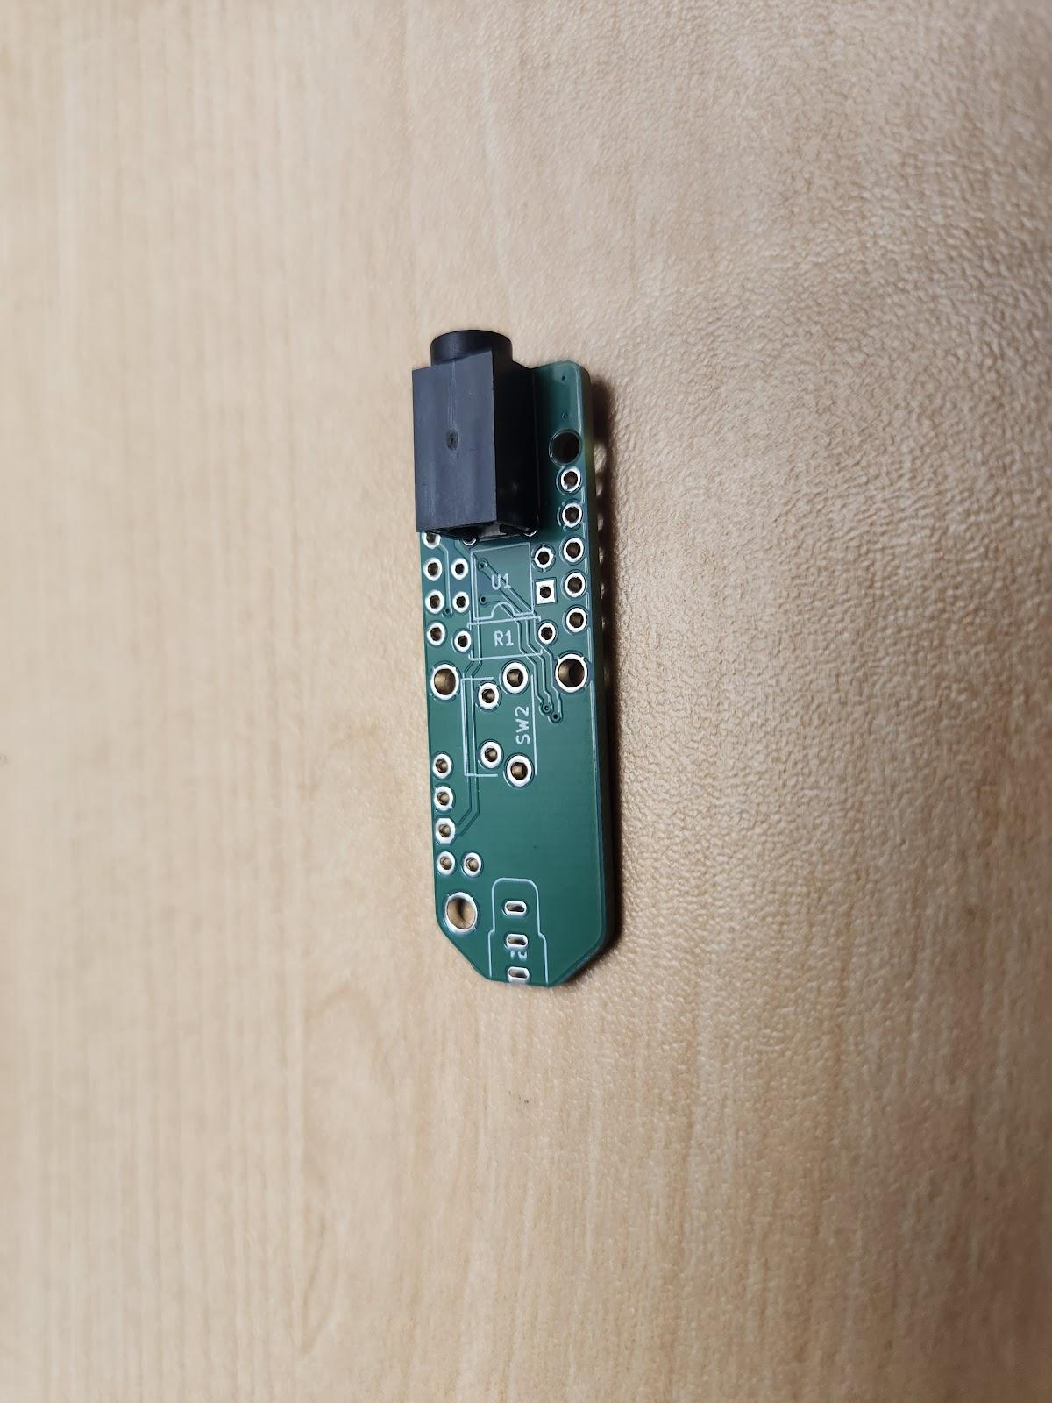Begin with the **blank PCB (A)** and **3.5 mm jack (D)**.

Insert the **3.5 mm jack** into the position labelled **J1** and line up the jack with the outline on the bottom of the blank PCB as shown.

Flip the board over and solder one pin of the 3.5 mm jack in place, ensuring it stays flat and straight.

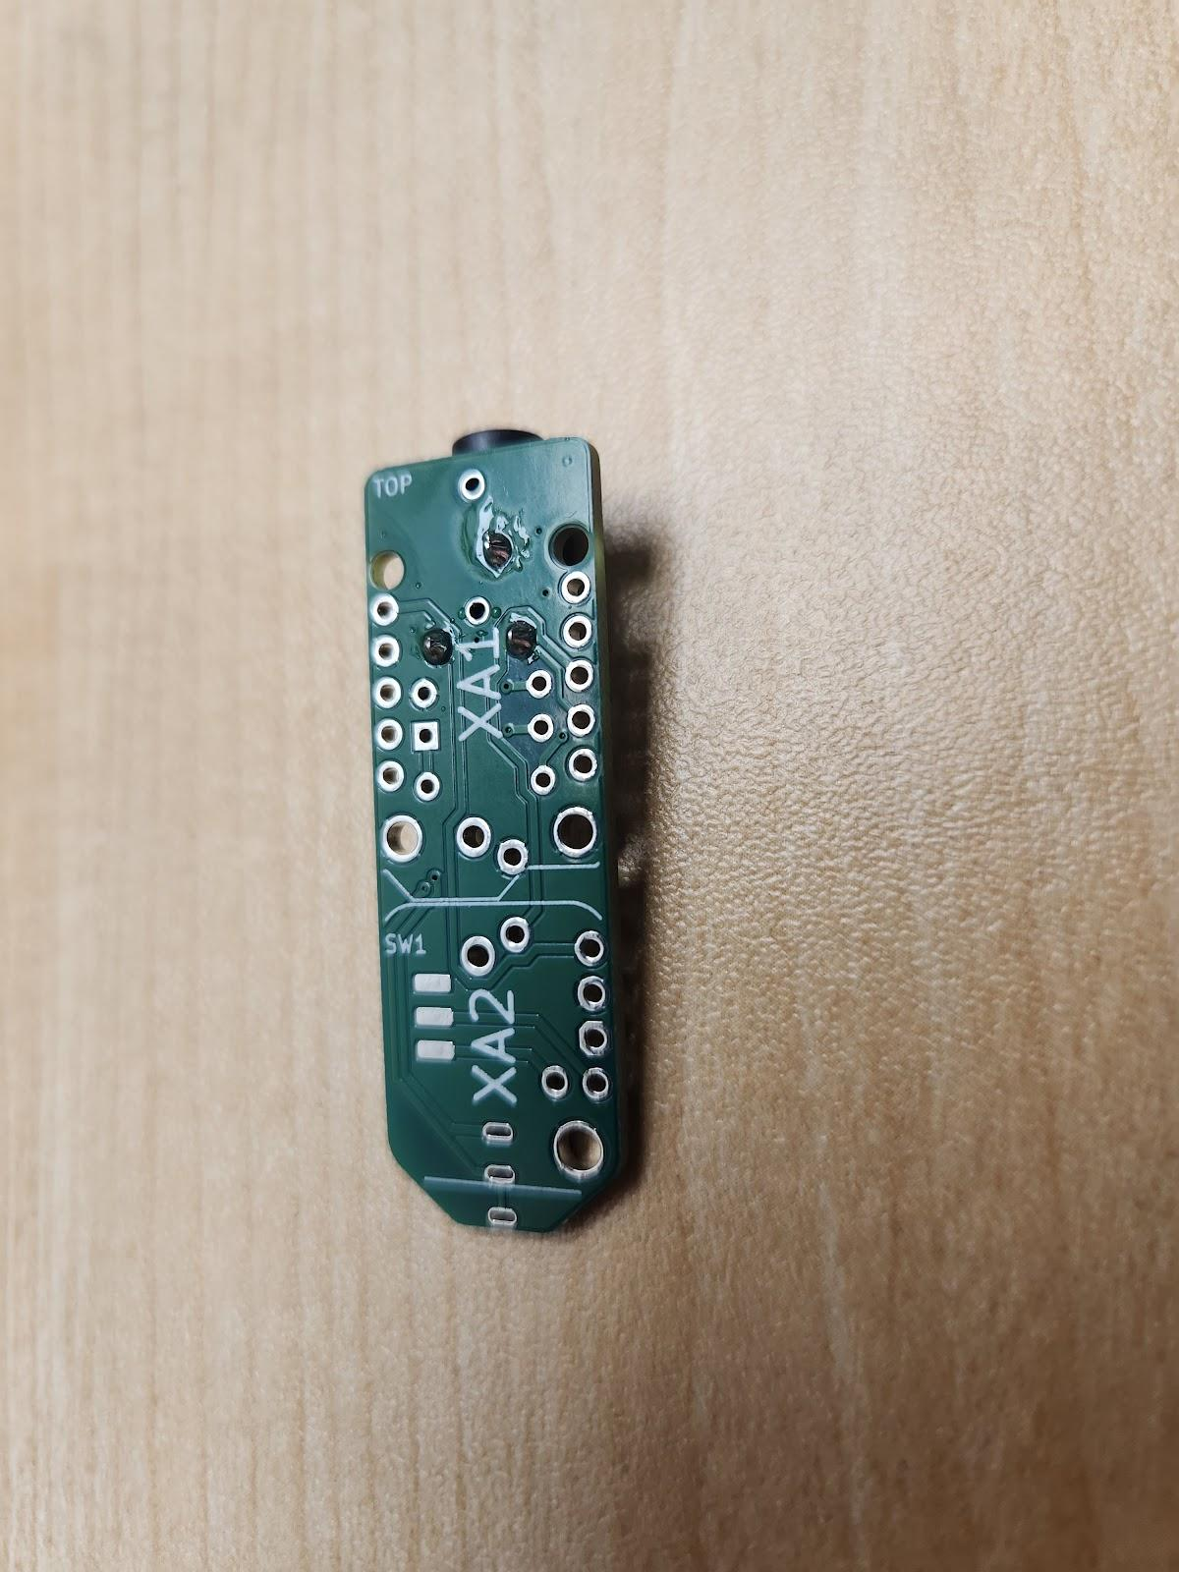

Check that the jack is straight and flat/flush to the board, if not reheat the solder joint and reposition.

Once properly positioned, solder the remaining 2 pins.

### Step 2: Insert and solder the Solid-State Relay

Insert the **solid-state relay (E)** into the positioned labelled **U1** and 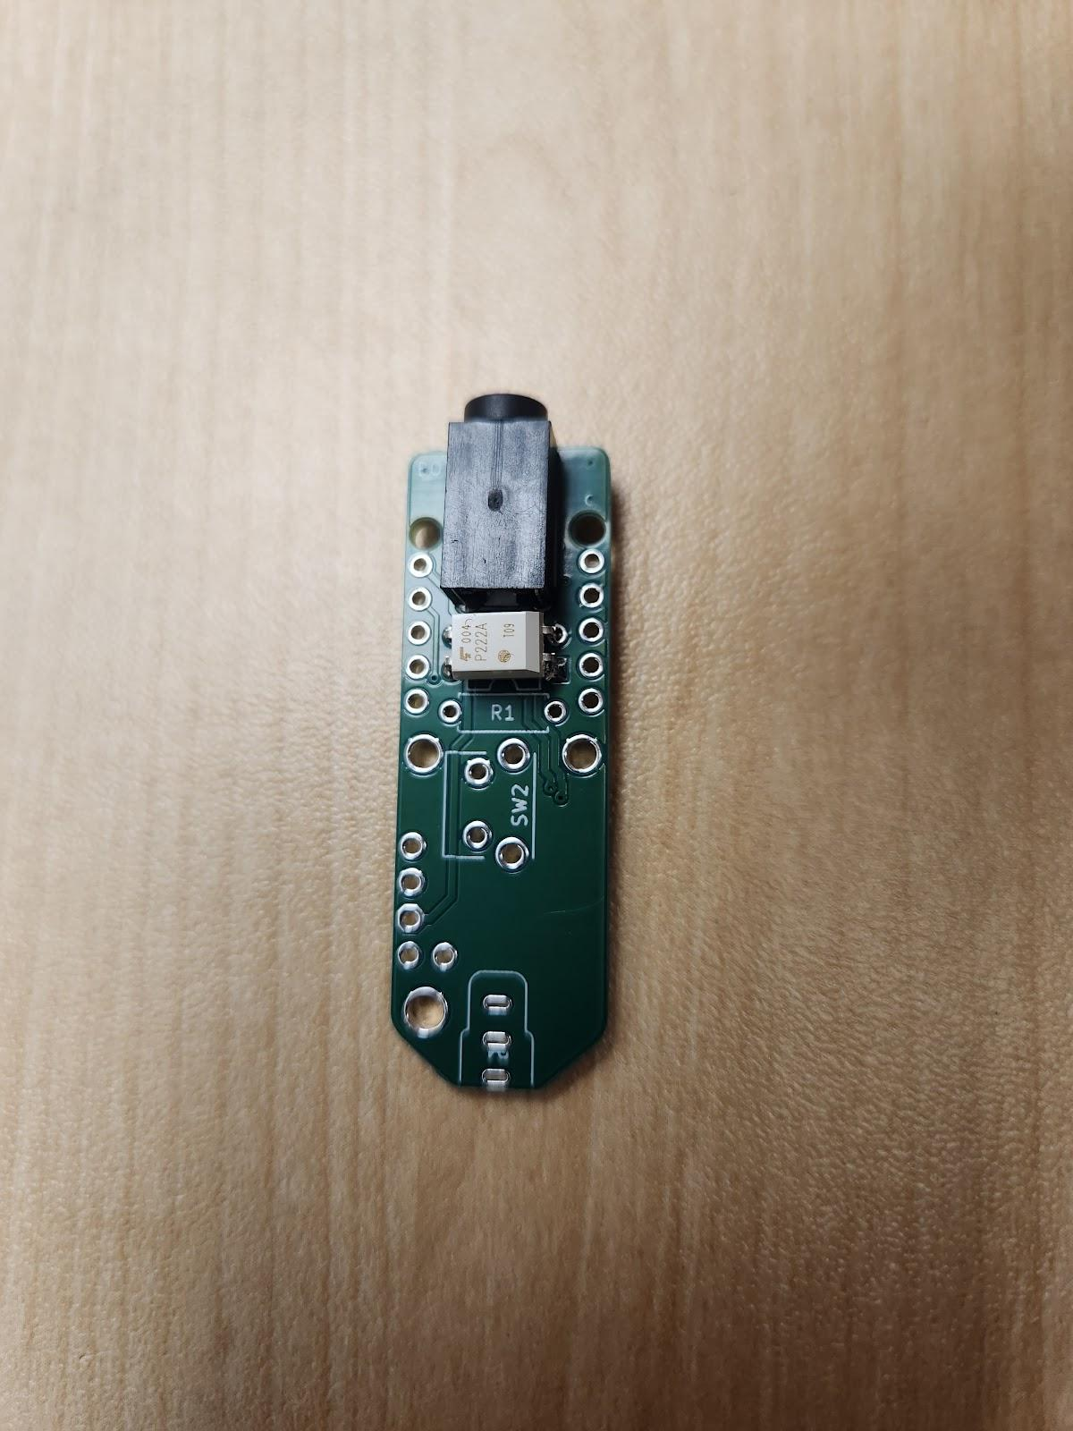line up with the outline on the PCB next to the 3.5 mm jack as shown.

Note that **orientation of the relay matters**. Ensure it matches the image shown, with the dot on the relay oriented towards the ‘notch’ outlined on the board, and furthest from the jack.

Flip the board over and solder the relay in place, ensuring it stays flat and straight.

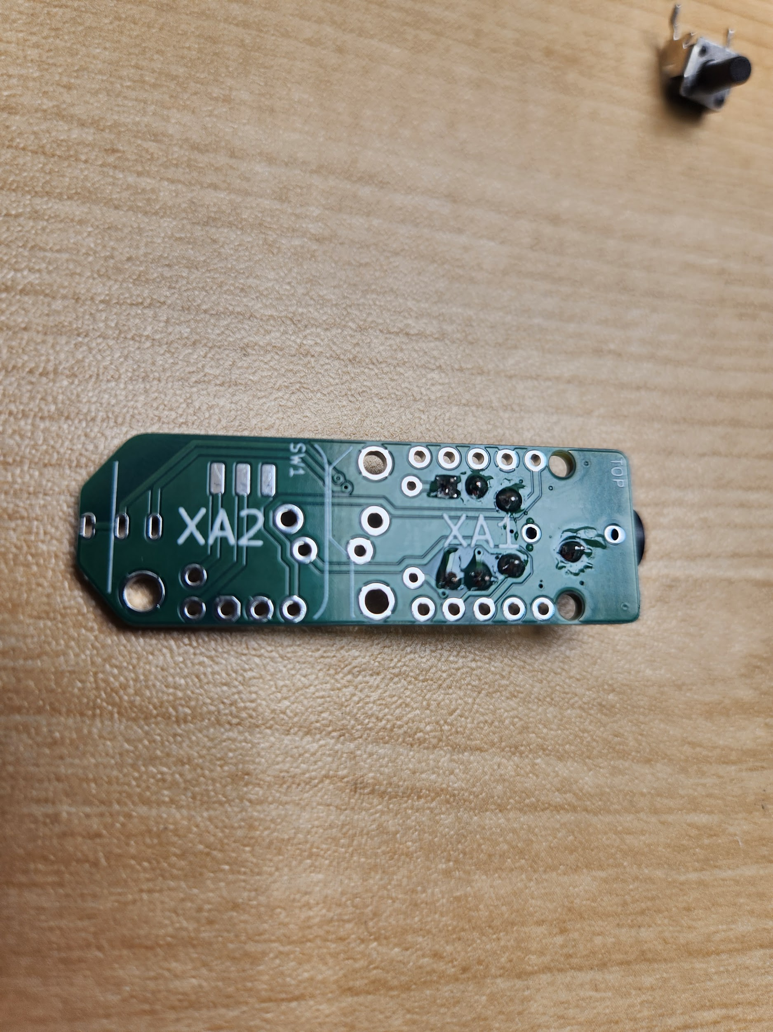

### Step 3: Insert and solder the Resistor

Bend the leads of the **resistor (F)** into a U-shape.

Insert the resistor into position R1, through the holes adjacent to the relay as shown. Orientation of the resistor **does not** matter.



Flip the board over and solder the leads of the resistor in place, then trim the leads of the resistor flush with the PCB.

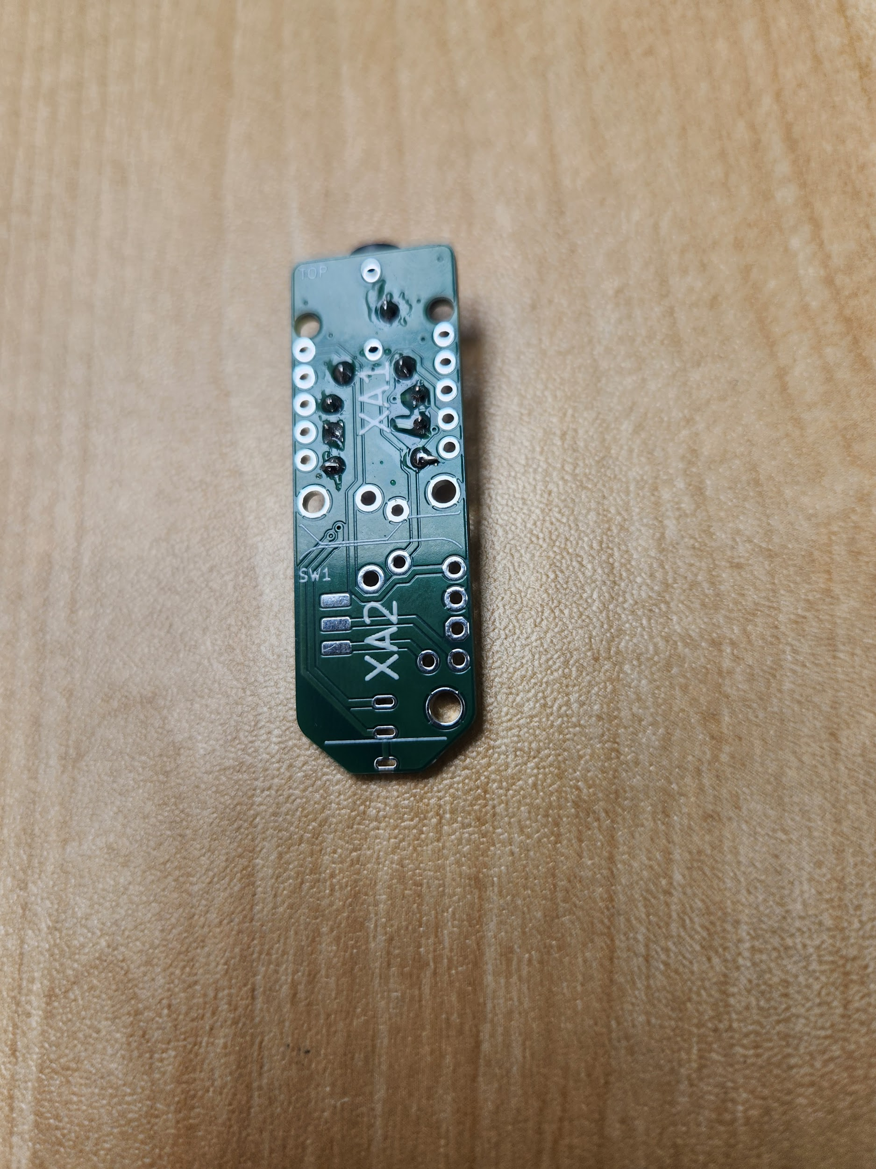

Your board should now look like this:

### Step 4: Insert and Solder the Push Button

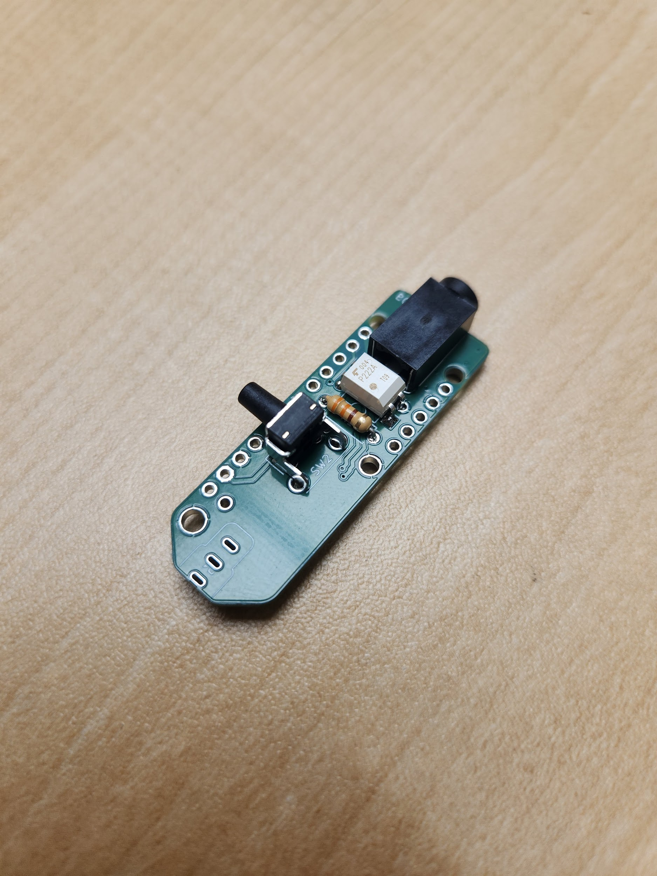Insert the **push button (G)** into position SW2 on the PCB as shown. It will only fit one way and will ‘snap’ into place.

Flip the board over and solder the push button in place.

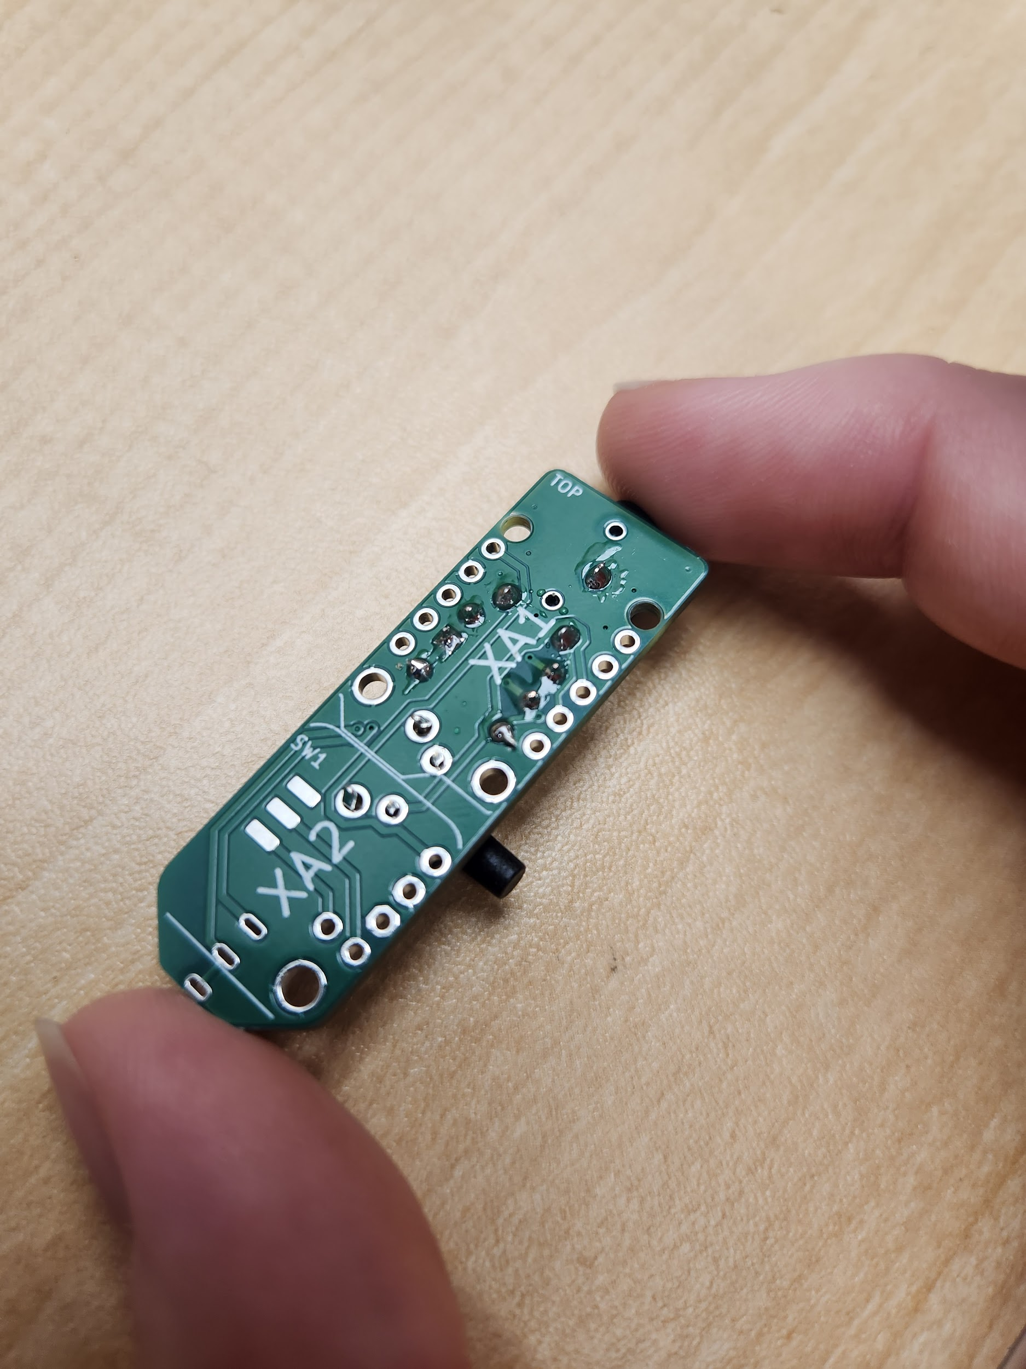

### Step 5: Position and Solder the Power Switch

Flip the PCB to the other side.

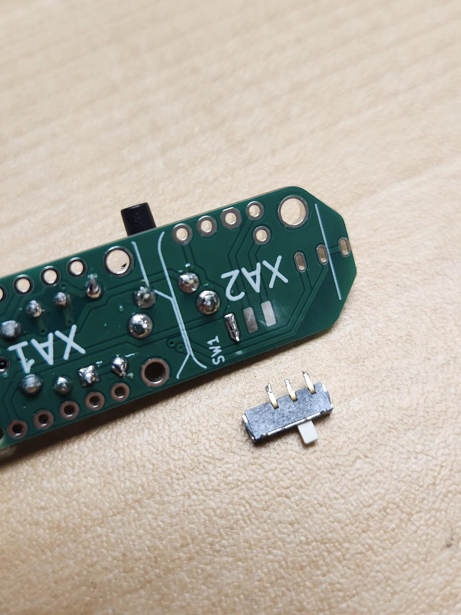The **power switch (H)** is soldered to the other side of the board, that doesn’t yet have any components soldered to it. At position SW1, apply a small dab of solder onto 1 of the 3 pads of the PCB as shown. **Tin** the bottoms of the leads of the power switch.

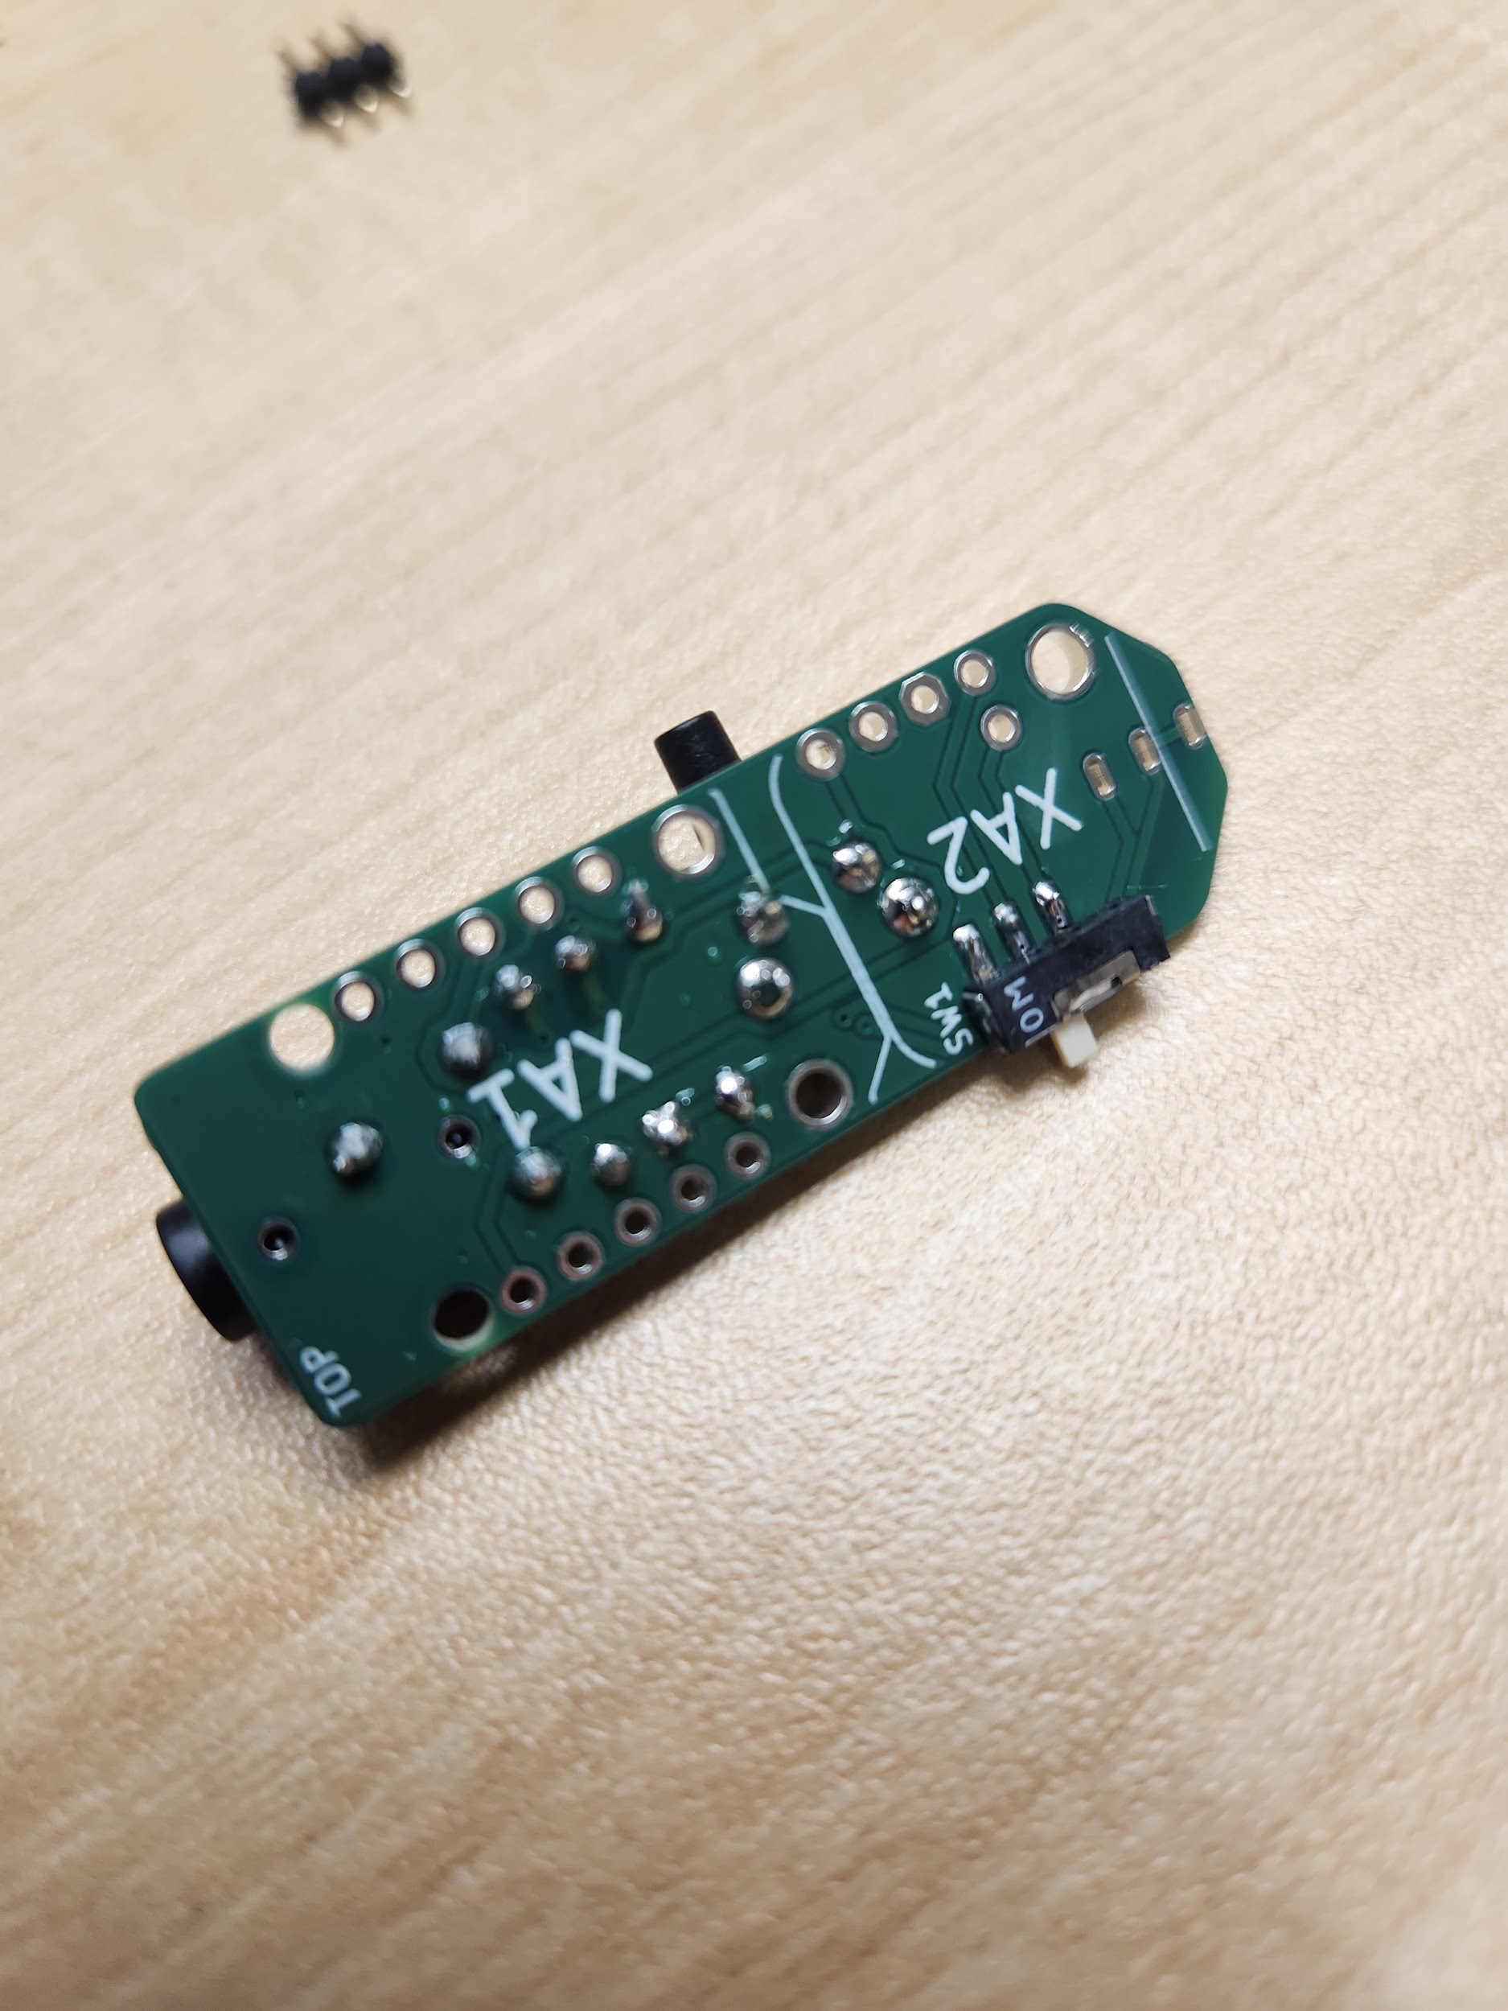Flip the power switch over and pinch the PCB and the power switch together. The “feet” of the switch will be flush with the edge of the PCB. Solder the first lead to the PCB. Ensure the switch is still flush with the PCB before soldering the other two leads.

Ensure soldering on each pad **doesn’t bridge**. Test the power switch with a multimeter to ensure it has been soldered properly. The power switch **cannot be accessed** after Step 8.

### Step 5.1: Testing the Power Switch

It is recommended you test the power switch following Step 5. This can be done using a multimeter. Put the multimeter in **continuity mode** and orient the PCB with the 3.5 mm jack to the left, and the power switch facing you.

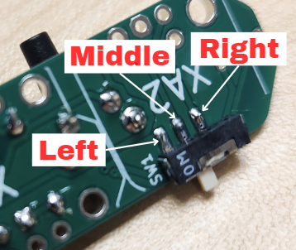

With the power switch to the **left**, touch the probes of the multimeter to the **left and right** pads of the power switch. If soldered correctly, the multimeter will beep.

With the power switch to the **right**, touch the probes of the multimeter to the middle and right pads of the power switch. If soldered correctly, the multimeter will beep.

### Step 6: Insert and Solder the Digital Output Plug

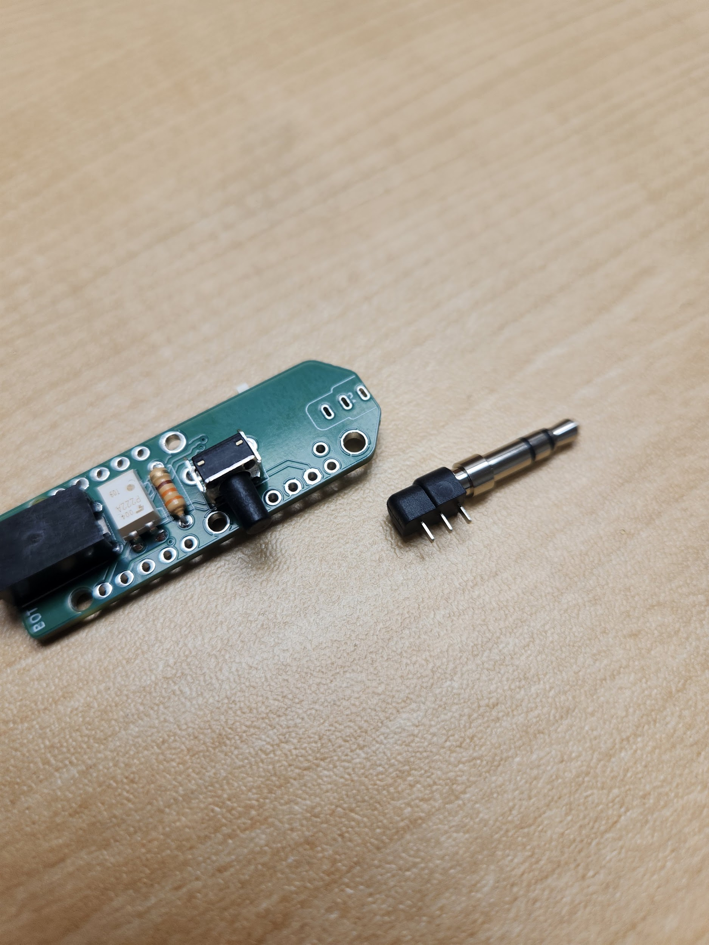

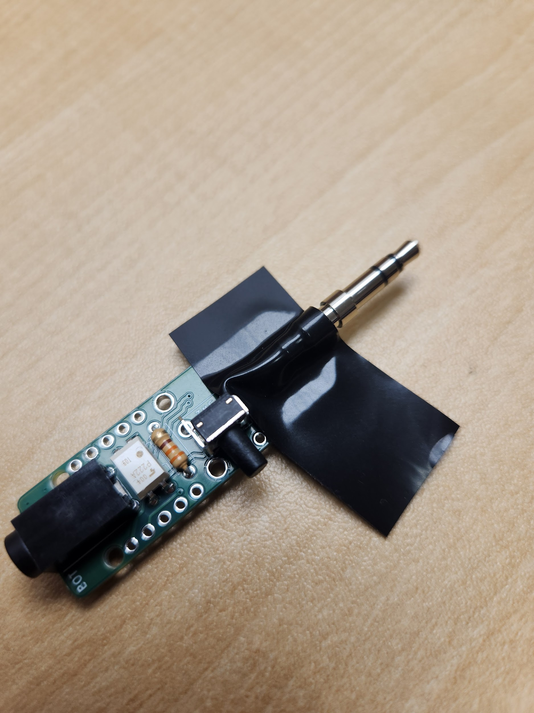Tape the **3.5 mm digital output plug (I)** in position on top of the PCB as shown, ensuring it is straight and flat. Flip the board over and solder **one** of the leads into place.

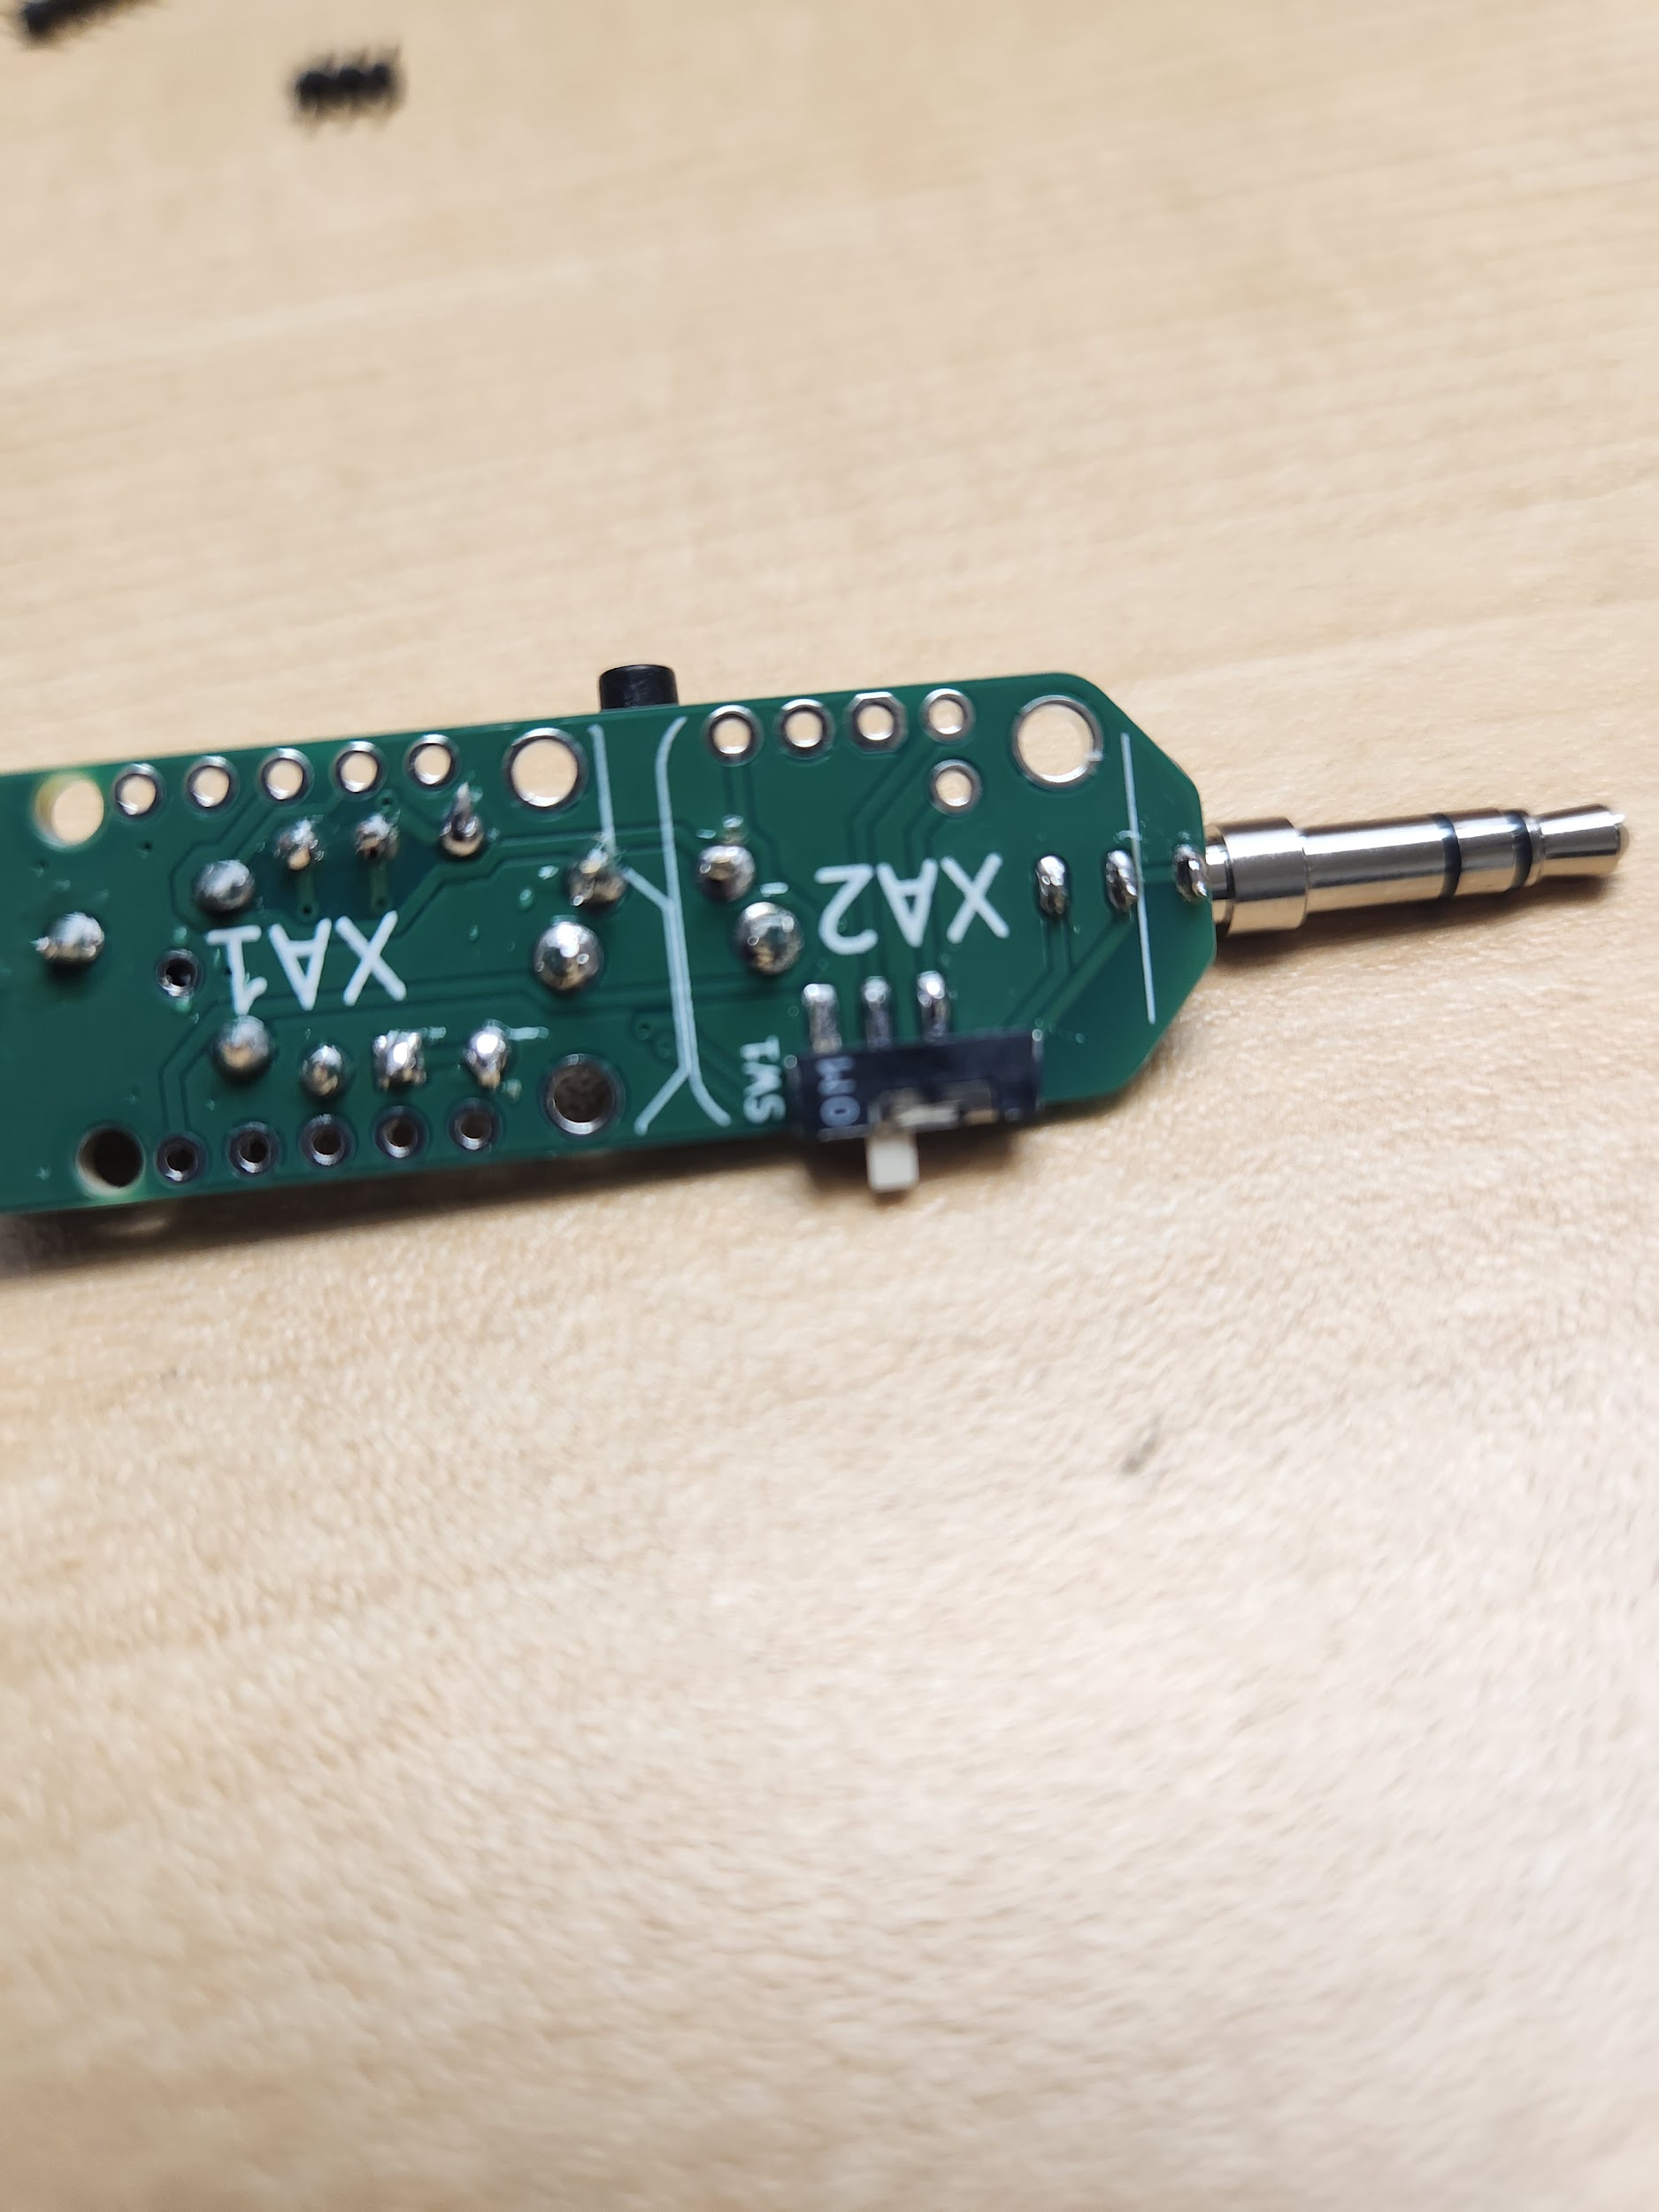

Remove the tape and check the positioning of the 3.5 mm digital output plug again before soldering the other two leads.

Your board should now look like this:

### Step 7: Insert and Solder the Trinket M0 Board

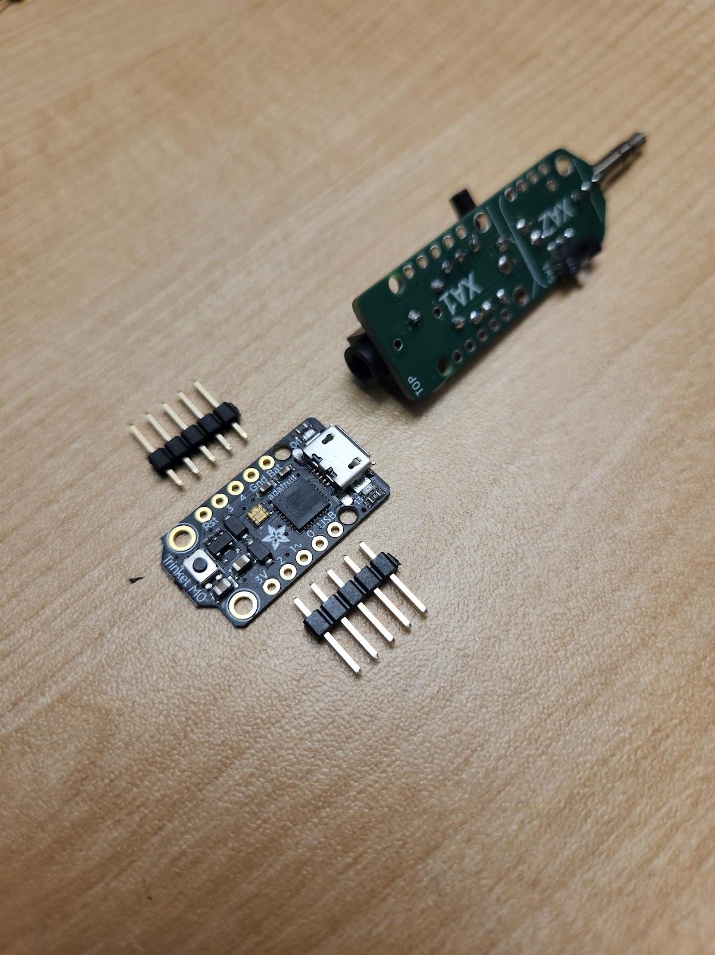To assemble the **trinket M0 board (B)**, place the two **5-pin headers (J)** with the long side down into the breadboard.

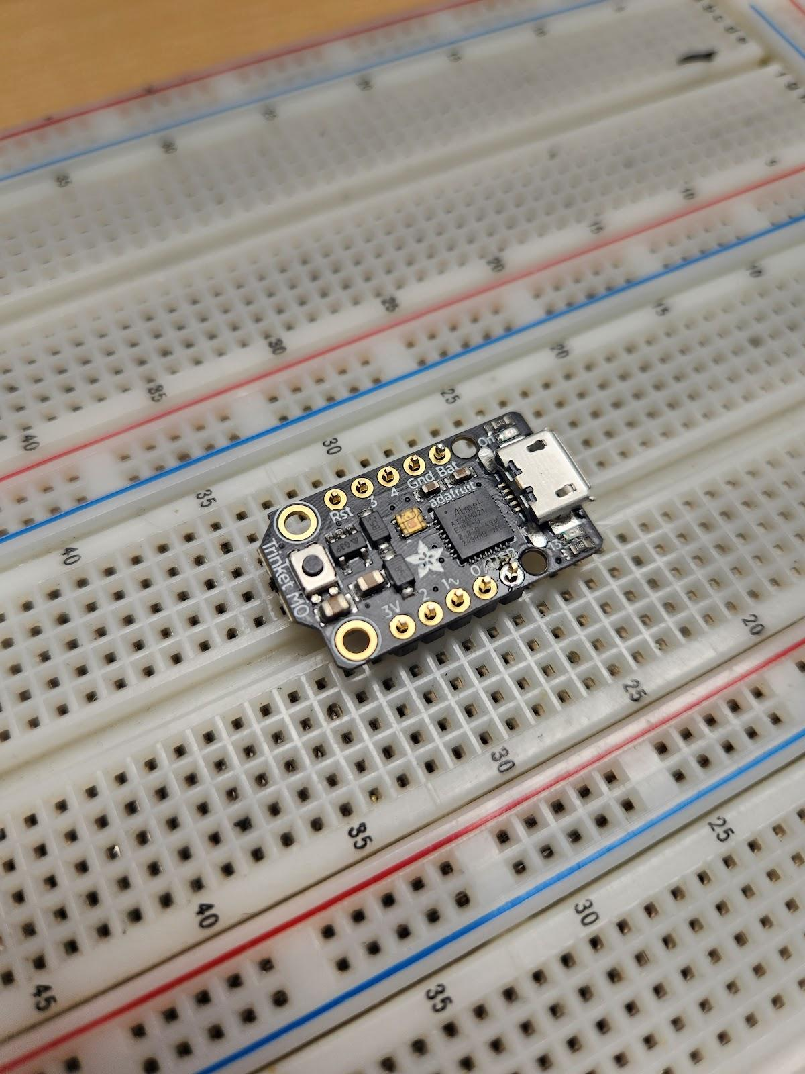

Line up the trinket M0 board with the 5-pin headers. Ensure you **do not** put the pins through the larger mounting holes on either side. Solder the 5-pin headers in place.

Alternatively, if you do not have a breadboard, you may use a clamp to hold the trinket M0 board while soldering the 5-pin headers in place. You will need to be diligent to ensure the headers are not crooked.

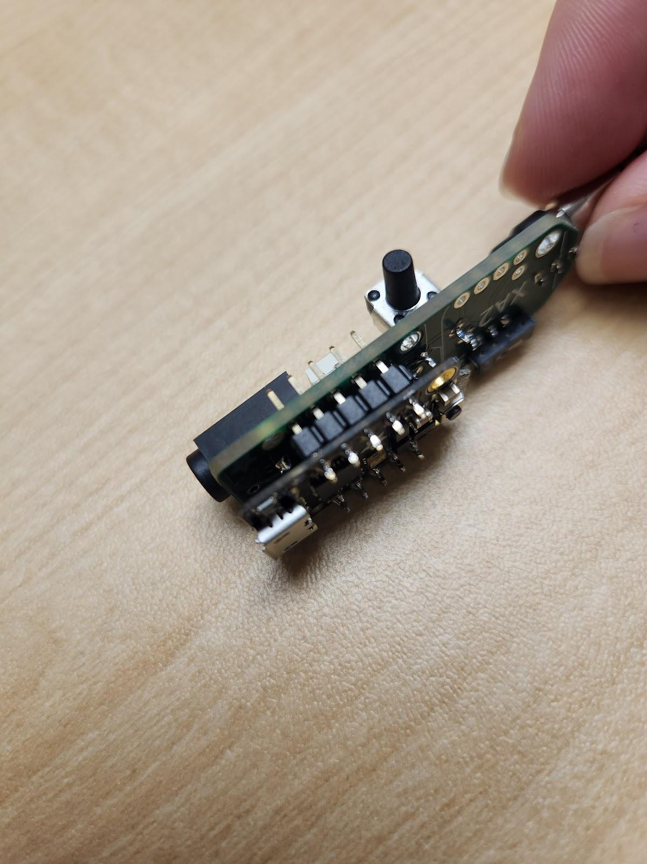

Insert the 5-pin headers from the Trinket M0 board into the XA1 position on the PCB. **Ensure the USB port is facing the nearest edge of the PCB.** Note that the trinket M0 board is mounted on the opposite side of the PCB to the 3.5 mm jack. Ensure you **do not** put the pins through the larger mounting holes on the PCB.

Solder one pin from the assembled Trinket M0 board to the PCB, check that the headers are flush with the PCB, and then solder the remaining pins. If the headers are not flush with the PCB reheat the solder joint to adjust the alignment before soldering remaining pins.

### Step 8: Insert and Solder the Power Supply Board

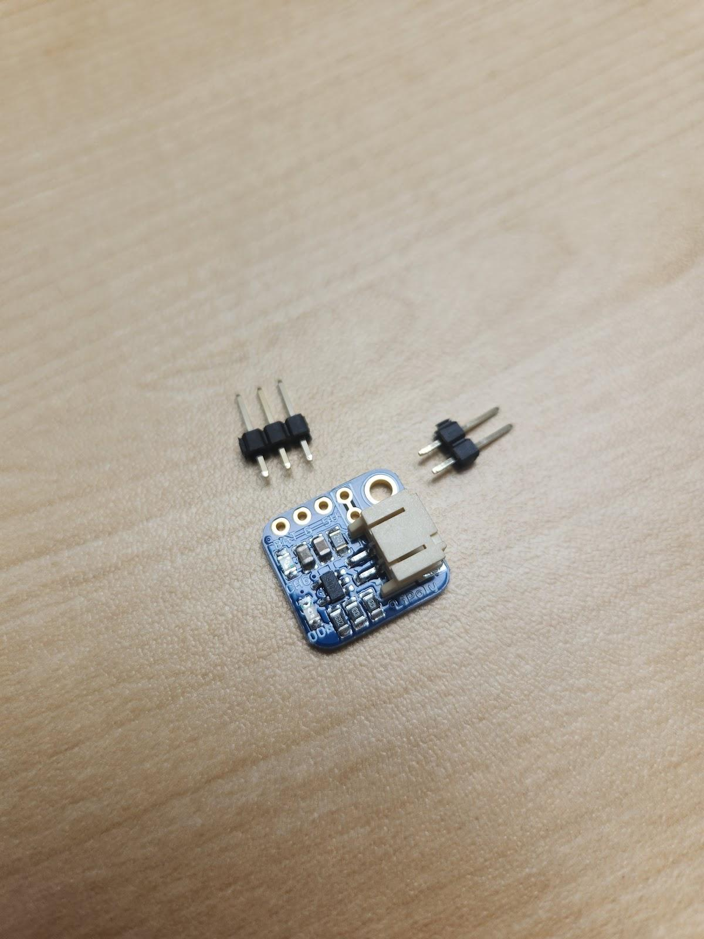Using the same process described in Step 7, assemble the **power supply board (C)**. The power supply board should be mounted on the **3- and** **2-pin headers (K & L)** as shown. Make sure the headers are soldered on straight and flush to the board.

### Step 9: Score Between Pins on Power Supply Board

Once the headers have been soldered, use a utility knife to score a line between the pins of the 2-pin header. This is a **necessary step** that prevents the board from being in an “always on” state. To check that this step was successful, remove the board from the breadboard, and using a multimeter in continuity mode, touch a lead to each pin and check that it does **not** beep.

### Step 10: Solder Power Supply Board to PCB

Insert the assembled board into the XA2 position on the PCB, lining up the 2- and 3-pin headers with the PCB. Note that the power supply board is mounted on the side of the board opposite to the 3.5 mm jack. Solder the assembled power board to the PCB, ensuring it is straight and flush to the PCB.

Your board should now look like this:

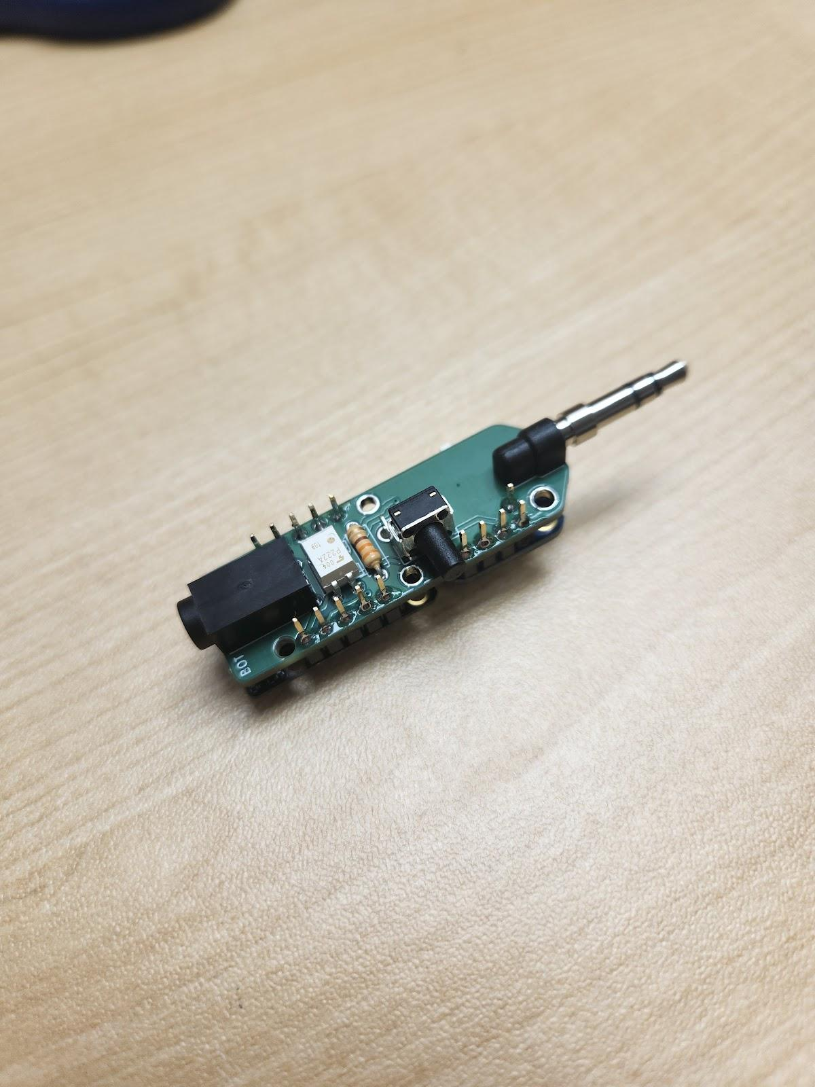 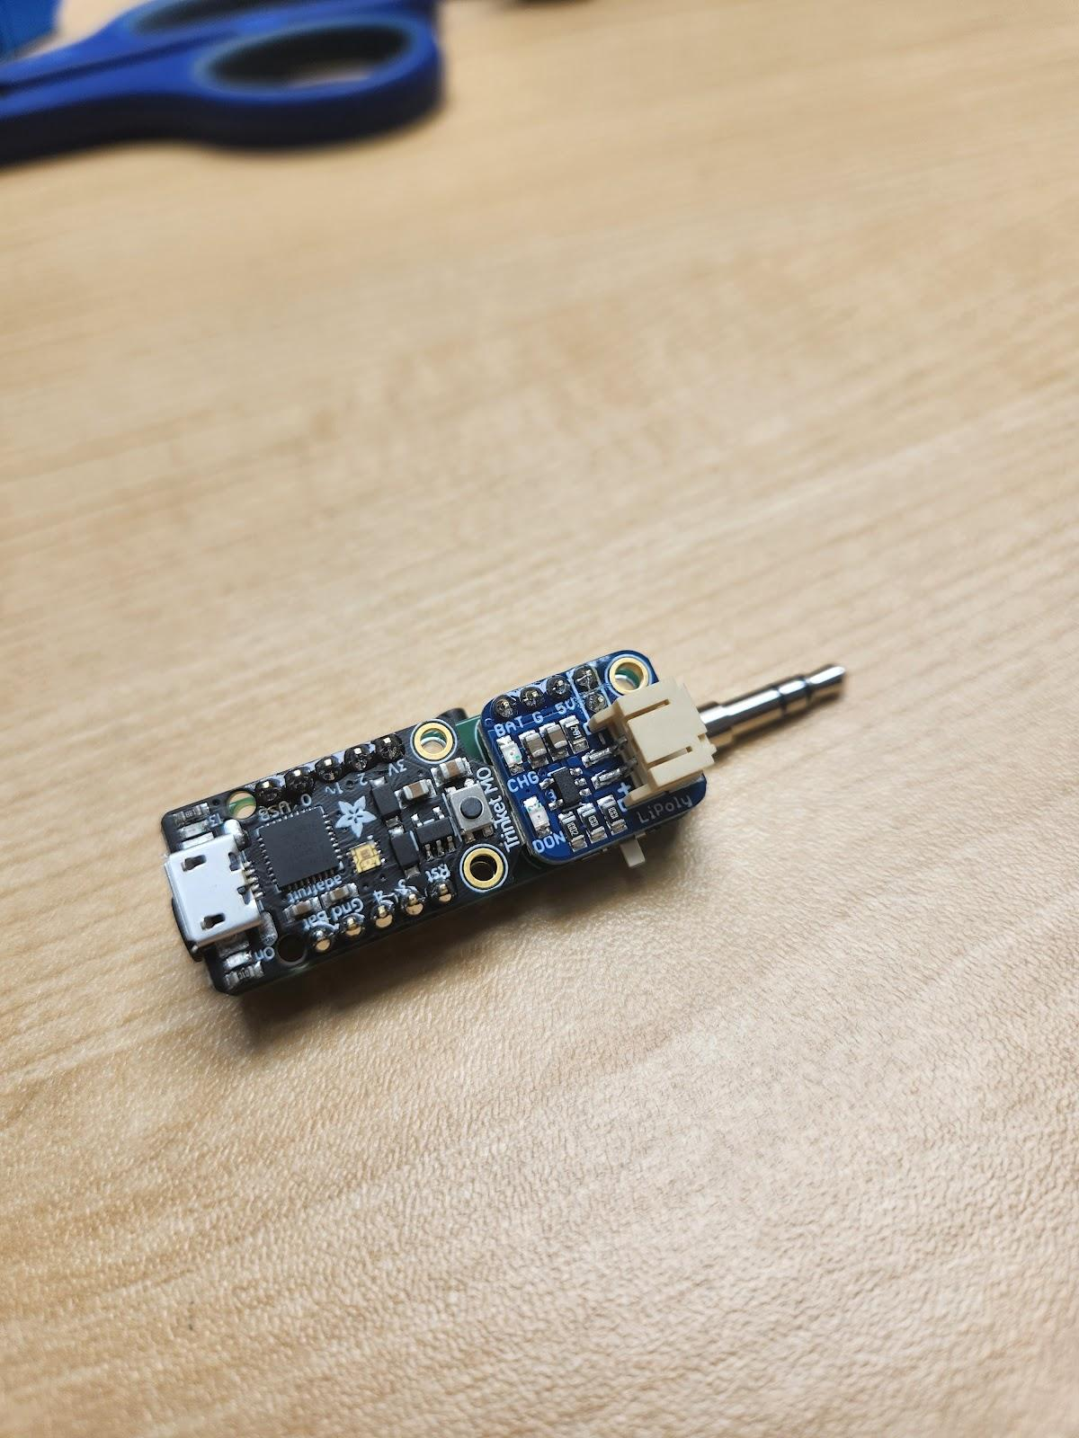

### Step 11: Position and Glue the Light Pipe

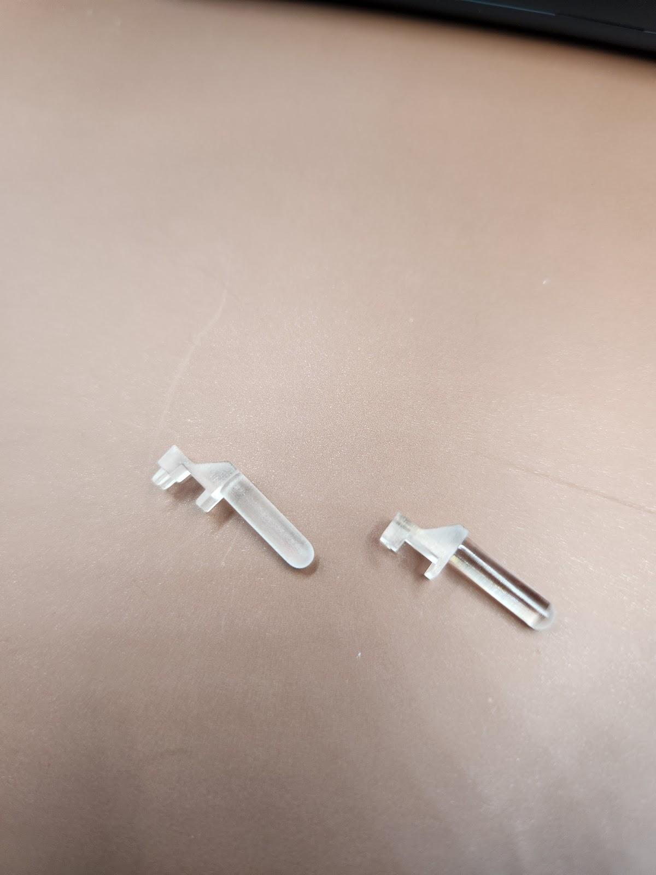Before attaching the light pipe (M), trim the ‘feet’ so that the base of the pipe will sit flush against the LED.



Locate the LED on the trinket M0 board. The light pipe will sit overtop the LED, projecting to the same side of the PCB as the push button.

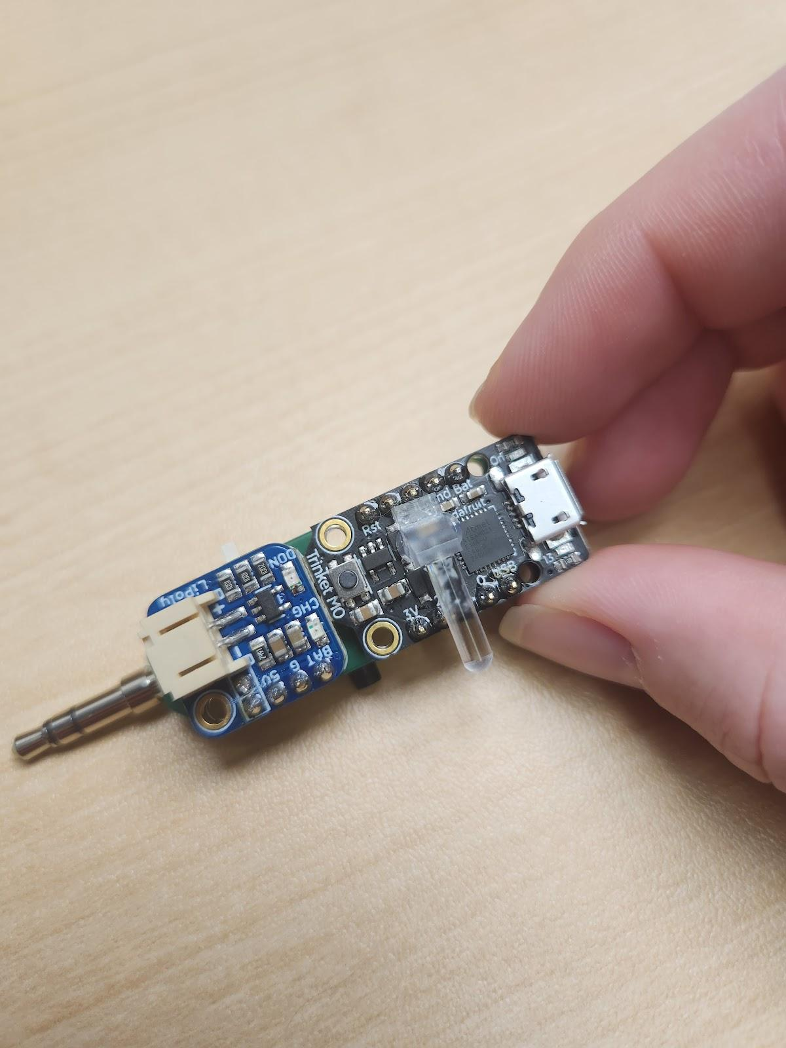

Apply a drop of hot glue to the base of the light pipe and press the light pipe into place, holding for a few seconds to allow the glue to set.

### Step 12: Final Assembly

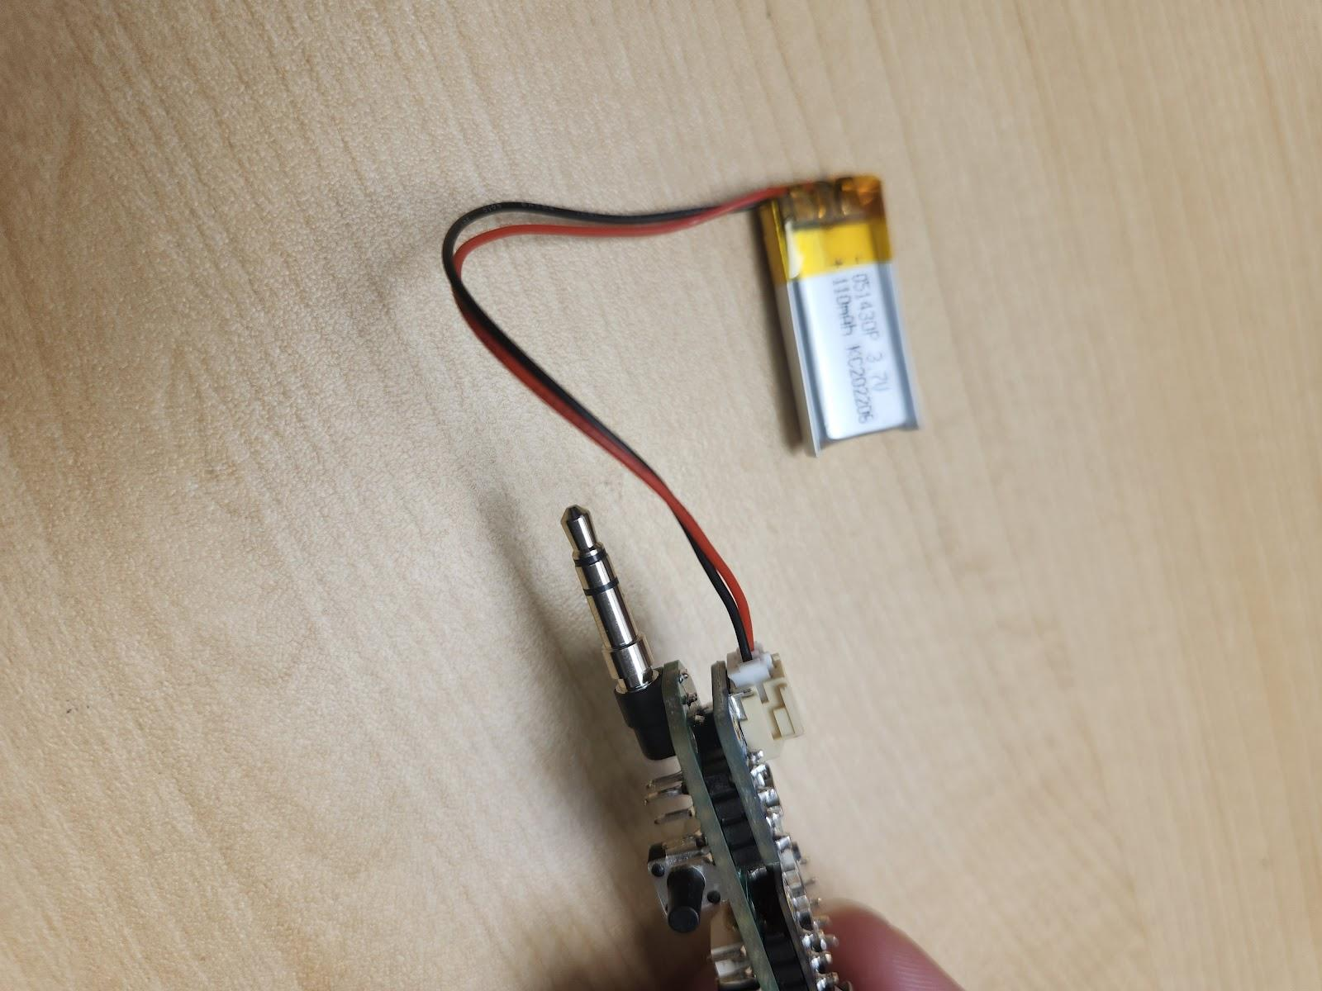Plug the **battery (N)** into the power supply board. If you do not possess a multimeter, test the power switch by turning the switch on and off, ensuring the device powers down. If the power switch is not working correctly, you will have to disassemble the board and return to Step 5.

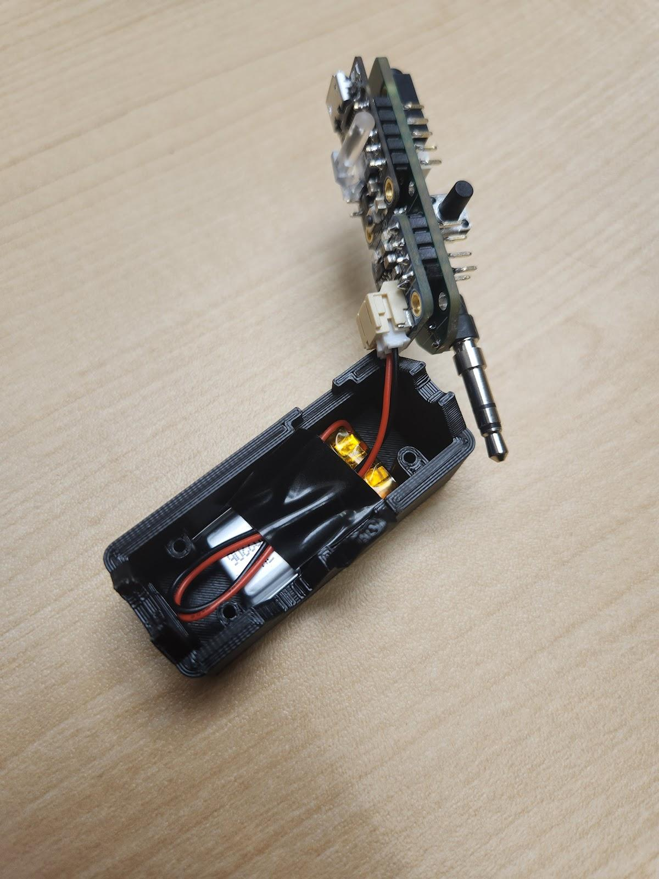Start with the lid of the **3D-printed case (O)** (the side of the case that has the text “Lift Switch”) upside-down. Place the battery in the lid, aligning the wires battery with the corner that **does not** have a screw hole. The battery should fit snugly in the case.

Fold the wires over, on top of the battery, and tape them in place with electrical tape. This ensures they do not get “pinched” by the circuit board.

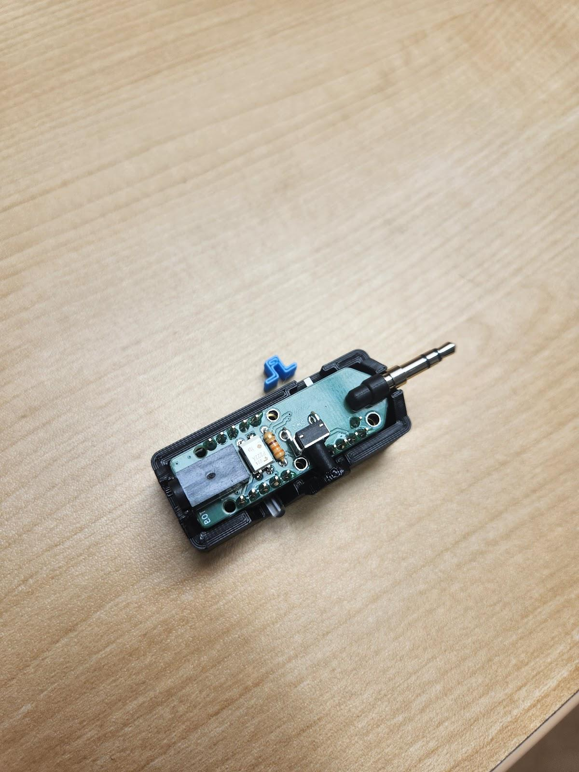Place the assembled PCB into the case overtop the wires. Ensure the 3.5 mm digital output plug and 3.5 mm jack align with their respective openings in the 3D-printed case.

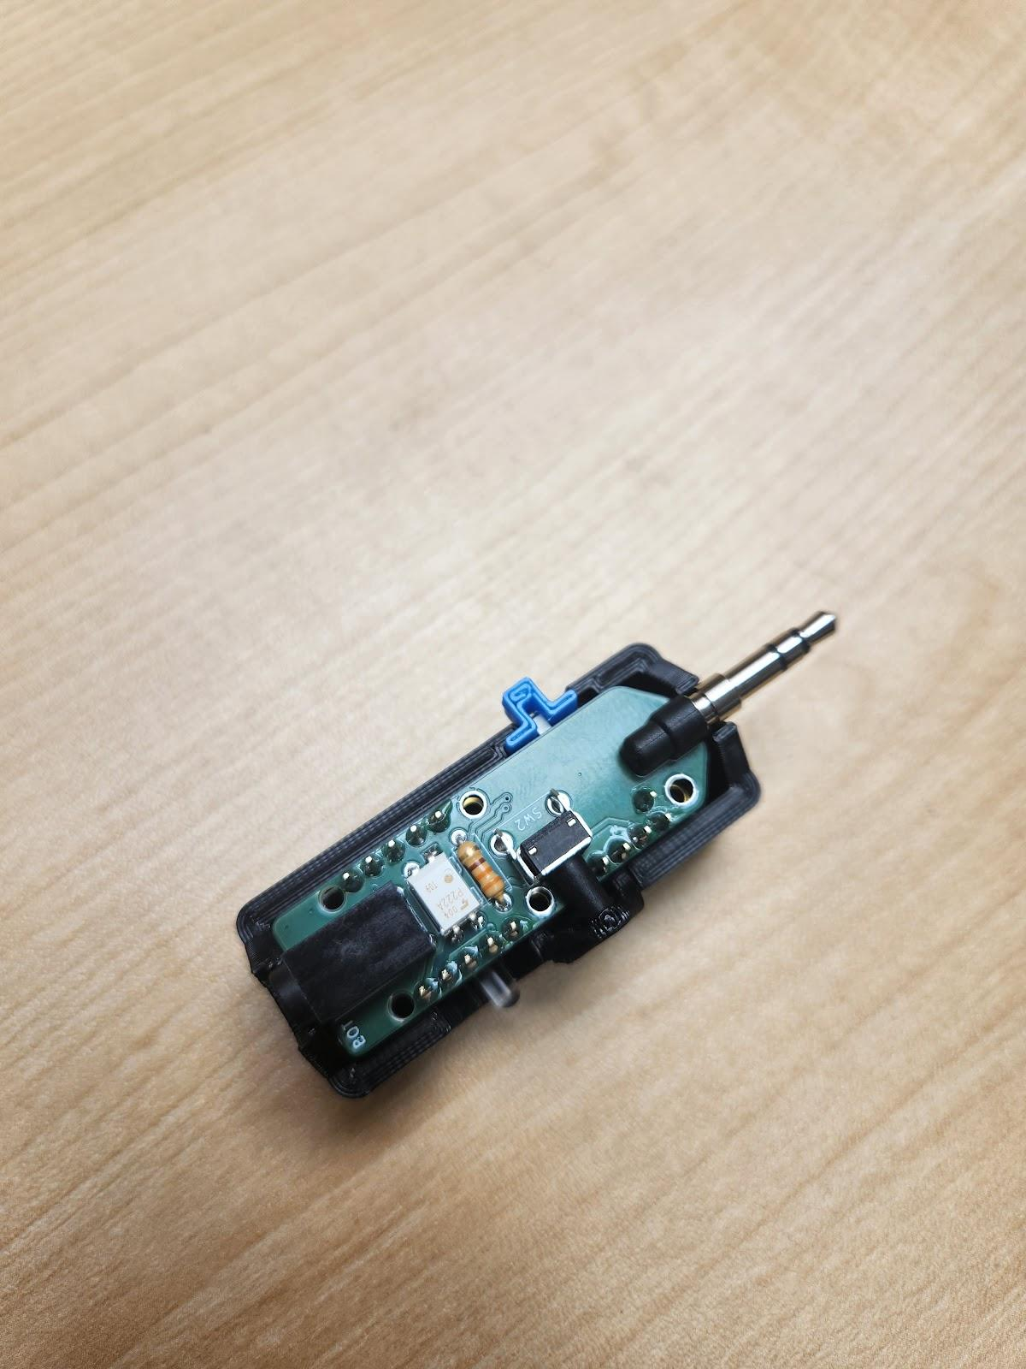Slide the **3d-printed switch cover (P)** into place overtop the power switch. You **should not** have to force the switch cover into place; doing so may break the power switch.

Place the base of the 3D-printed case into position and screw together using the 3 **screws (Q)**. Do not overtighten the screws.

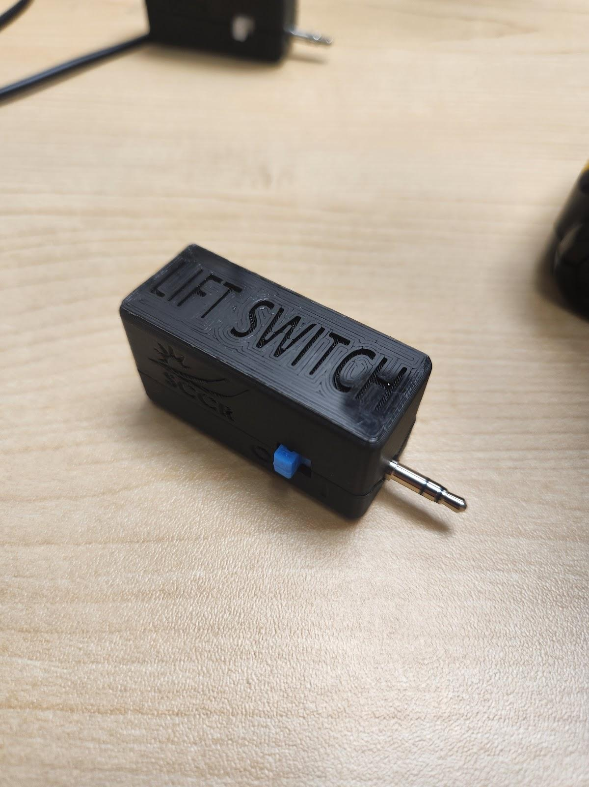Your Lift Switch is now assembled!

You can now proceed to the Flashing Instructions.

## **Firmware Flashing Instructions**

### Step 1: Setup Arduino IDE

1. Download Arduino IDE for your operating system at <https://www.arduino.cc/en/software>
2. Install the Arduino IDE.

### Step 2: Setup Arduino IDE for Adafruit Trinket M0 Board

1. Open Arduino IDE.
2. Click on **File -> Preferences**.
3. Locate the text field that says **Additional Boards Manager URLs** beside it.
4. Copy and paste the following link into the field as a new line: <https://adafruit.github.io/arduino-board-index/package_adafruit_index.json>
5. Click on **OK.**
6. Restart the Arduino IDE.
7. Open the **Boards Manager** option from the **Tools-> Board-> Boards Manager...,**
8. **Search for “Adafruit SAMD” and select “Adafruit SAMD Boards” by Adafruit.**
9. **Click Install to install the board.**

### ****Step 3: Install Libraries****

1. Go to **Tools -> Manage Libraries…,** search for “Flash Storage” and install the library “FlashStorage” by Various or Arduino.
2. Go to **Tools -> Manage Libraries…,** search for “Adafruit DotStar” and install the library “Adafruit DotStar” by Adafruit.

### Step 4: Setup Local Code Directory

1. Download the Firmware_Files from the GitHub Repository: <https://github.com/makersmakingchange/Lift-Switch/raw/main/Build_Files/Firmware_Files/LiftSwitchFirmware.zip>
2. Extract / unzip the folder to a known location.

### Step 5: Upload the Code to the microcontroller.

1. Open LiftSwitchFirmware.ino with Arduino IDE.
2. **Select Adafruit Trinket M0 (SAMD21) from Tools -> Board -> Adafruit SAMD Boards**
3. Click on **Tools -> USB Stack** and select **TinyUSB**
4. Connect the Forest Hub using the USB cable to the computer.
5. Select the correct port from **Tools -> Port** menu.
6. Verify and upload the code.

# Testing

Turn the power switch into the on position. The LED will blink purple, then will change colour to indicate the current mode. Note that the Lift Switch ‘remembers’ the last mode it was in.

Change the modes by pressing the mode button, located on the opposite side of the power switch. The Lift Switch will cycle through the modes.

Test each mode of the Lift switch using a Switch Tester (or other switch-adapted item you possess) and an accessible switch. Please refer to the user guide for descriptions of the modes.